**To complete this activity, follow the steps below:**

1. Download the [Activity 12.3](https://classroom.emeritus.org/courses/8898/files/2299883/download) folder. In a Word document, include a screenshot demonstrating that you were able to open the folder in VS Code. Note that for this activity you will need to modify the files provided.

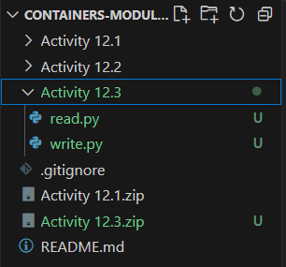

1. Use Redis to create a Docker *container*. Use port 6379 and name your *container* “activity12.3”. Provide two screenshots: The first screenshot should show that you successfully ran the command to create the *container* in your Terminal window. The second screenshot should show that the *container* you just created is active on Docker.



1. Open the write.py file from the folder you downloaded. Use the Redis *method*, mset, to create a *dictionary*, r, with *keys* equal to Italy and France and corresponding values equal to Rome and Paris. Provide a screenshot of the code you wrote.

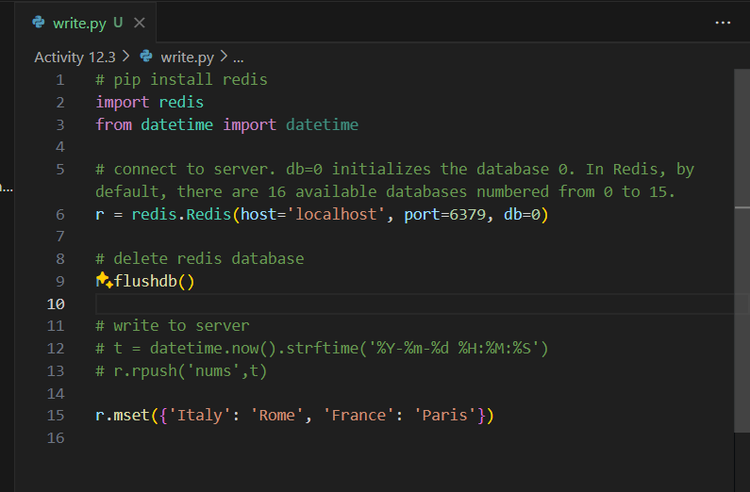

1. Run the write.py file in your Terminal window to show that your syntax does not contain any errors. Provide a screenshot.



1. Open the read.py file from the folder you downloaded. Use the Redis *method*, get, to read all values in r. Provide a screenshot of your updated code.

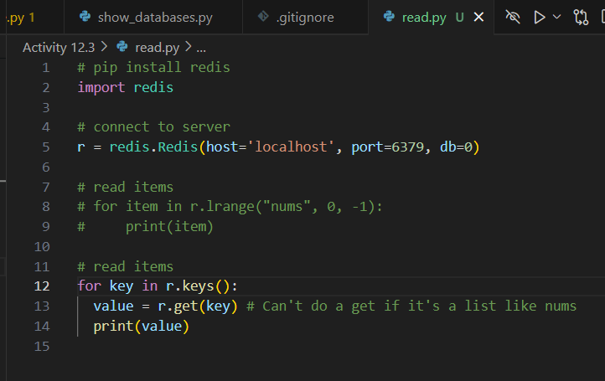

1. Run the read.py file in your Terminal window to show that your code prints the *dictionary* values correctly.

